# EXPRESS EDUCATION SERVICES LIMITED – 2024

# PRIMARY LEAVING SPECIAL MOCK

INTERGRATED SCIENCE

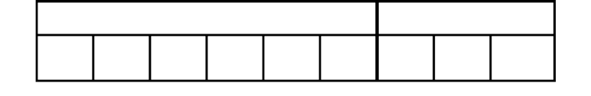***Time Allowed: 2 Hours 15 Minutes***

# Index No.

**Random No. Personal No.**

**Candidate’s Name:**

**Candidate’s Signature:**

**DISTRICT ID NO.**

|  |  |  |  |
| --- | --- | --- | --- |
|  |  |  |  |

**Read the following instructions carefully:**

|  |  |  |
| --- | --- | --- |
| **FOR EXAMINERS ONLY** | | |
| **Qn. No.** | **MARKS** | **EXR’S NO** |
| 1 - 10 |  |  |
| 11 - 20 |  |  |
| 21 - 30 |  |  |
| 31- 40 |  |  |
| 41 - 43 |  |  |
| 44 - 46 |  |  |
| 47 - 49 |  |  |
| 50 - 52 |  |  |
| 53 - 55 |  |  |
| **TOTAL** |  |  |

2024 SPECIAL MOCK

1. Do not forget to write your **school** or **district name**

on the paper.

1. This paper has two sections: **A** and **B**. Section **A** has **40** questions and section **B** has **15** questions. The paper has **14** printed pages.
2. Answer **all** questions. **All** working for both sections

**A** and **B** must be shown in the spaces provided.

1. **All** answers **must** be written using a **blue** or **black** ball point pen or ink. Any work written in pencil will **not** be marked.
2. Unnecessary **changes** in your work and handwriting that cannot be read easily may lead to **loss of marks**.
3. Do not fill anything in the table indicated: **“For Examiners’ use only”** and boxes inside the question paper.



**TURN OVER**

# SECTION A: 40 MARKS

* 1. Name the element of weather that helps in winnowing

……………………………………………………………………………………………………………………………

* 1. How long will chicken eggs take to hatch when put in an incubator?

……………………………………………………………………………………………………………………………

* 1. Name the germ which causes trachoma

……………………………………………………………………………………………………………………………

* 1. State the function of the chisel(wedge) shaped teeth in the mouth

……………………………………………………………………………………………………………………………

* 1. Why is open castration method suitable for boar pigs?

………………………………………………………………………………………………………………………

Use the diagram below to answer 6 and 7

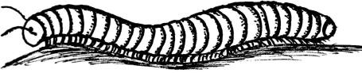

* 1. Name the invertebrate shown

……………………………………………………………………………………………………………………….….....

* 1. How does the invertebrate protect its self?

……………………………………………………………………………………………………………………………..

Turn over

* 1. How do engineers provide room for expansion during construction of the railway?

……………………………………………………………………………………………………………………………

* 1. What do we call blood vessels that carry blood away from the heart?

……………………………………………………………………………………………………………………………

* 1. Identify the form of energy needed to cook food in the kitchen

……………………………………………………………………………………………………………………………

* 1. Name the digestive disorder which results from excessive drinking of alcohol.

……………………………………………………………………………………………………………………………

* 1. Give any one drug people in your community abuse by smoking

……………………………………………………………………………………………………………………………

* 1. What type of change is burning?

……………………………………………………………………………………………………………………………

* 1. Write down the PIASCY message which controls teenage pregnancy.

……………………………………………………………………………………………………………………………

* 1. What do birds with sharp curved talons and sharp hooked beaks feed on?

……………………………………………………………………………………………………………………………

Turn over

* 1. Give a reason why petrol and water cannot mix uniformly when put in the same container.

……………………………………………………………………………………………………………………………

* 1. Name the musical instrument shown below

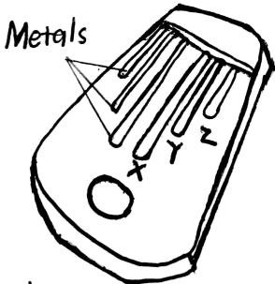

……………………………………………………………………

* 1. Which metal on the above musical instrument will produce the lowest pitch

……………………………………………………………………………………………………………………………

* 1. Name the vector for elephantiasis

……………………………………………………………………………………………………………………………

* 1. In which way is the iris of the eye similar to the diaphragm of the lens camera?

……………………………………………………………………………………………………………………………

* 1. Name the component of loam soil which makes it better than any other type of soil.

……………………………………………………………………………………………………………………………

Turn over

* 1. Kato pushed carried a 50kg bag of cement through 15metres.

Calculate the work done by Kato

* 1. State any one role of a school health committee

……………………………………………………………………………………………………………………………

* 1. Why do farmers carry out gap filling?

……………………………………………………………………………………………………………………………

* 1. Name the type of breeze which occurs at night

……………………………………………………………………………………………………………………………

* 1. How is hepatitis B controlled in infants?

……………………………………………………………………………………………………………………………

* 1. Give any one method of preserving animal hides.

……………………………………………………………………………………………………………………………

* 1. In the space below, draw a blood component destroyed by HIV

Turn over

* 1. How is a catcher box important to an apiculturist?

……………………………………………………………………………………………………………………………

* 1. Why is chicken pox called a contagious disease?

……………………………………………………………………………………………………………………………

* 1. State the importance of water during seed germination.

……………………………………………………………………………………………………………………………

* 1. Give any one example of a primary cell.

……………………………………………………………………………………………………………………………

* 1. State the similarity between a dove and an echidna in terms of reproductions.

……………………………………………………………………………………………………………………………

* 1. Give the meaning of term demography

……………………………………………………………………………………………………………………………

……………………………………………………………………………………………………………………………

* 1. There are terrestrial organisms in the environment. Give any one animal that belong to such organisms

……………………………………………………………………………………………………………………………

Turn over

* 1. Identify the mode of reproduction shown below

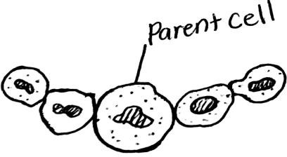

……………………………………………………………………………

* 1. Name the fungus which undergoes the mode of reproduction shown above

……………………………………………………………………………………………………………………………

* 1. How does breast feeding control pregnancy in females?

……………………………………………………………………………………………………………………………

* 1. Give the cause of a short circuit in an electric circuit.

……………………………………………………………………………………………………………………………

* 1. Give the importance ears to a goat.

……………………………………………………………………………………………………………………………

Turn over

# SECTION B: 60 MARKS

Questions **41** to **55** carry four marks each.

* 1. a) Give any one sign of marasmus in infants

……………………………………………………………………………………………………………………………

1. Give any two foodstuffs a mother can use to control marasmus in her children
   1. …………………………………………………………………………………………………………………………
   2. …………………………………………………………………………………………………………………………
2. Besides marasmus, give any other malnutritional disease in infants.

……………………………………………………………………………………………………………………………

# Use the diagrams below to answer questions that follow

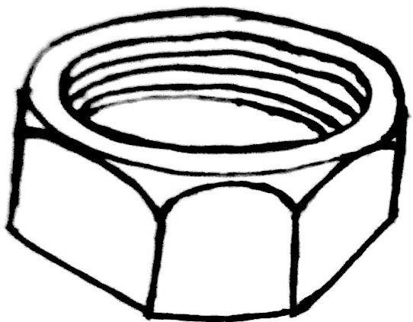

* + 1. Name the simple machine shown

…………………………………………………………………………………………….…………..…………………

Turn over

* + 1. To which group of simple machines does it belong?

………………………………………………………………………………………………………………….…………

* + 1. Give any other example of tool that belong to the same group

……………………………………………………………………………………………………………………………

* + 1. Give the force which affects the proper working of the tool shown above

……………………………………………………………………………………………………………………………

* 1. a) Give the meaning of the term excretion

…………………………………………………………………………………………………………………………….

……………………………………………………………………………………………………………………………

1. Why are the following called excretory organs?
   1. Lungs

……………………………………………………………………….……………………………………………………

……………………………………………………………………………………………………………………………

* 1. Kidney

……………………………………………………………………..………………………………………………………

……………………………………………………………………………………………………………………………

1. Give the importance of excretion to the body

……………………………………………………………………………………………………………………………

……………………………………………………………………………………………………………………………

Turn over

* 1. a) Give the importance of ventilations on a house

……………………………………………………………………………………………………………………………

1. Mention any two factors considered before constructing a house i)…………………………………………………………………………………………………………………

ii) …………………………………………………………………………………………………………………………

1. Besides marasmus, give any other malnutritional disease in infants.

……………………………………………………………………………………………………………………………

* 1. 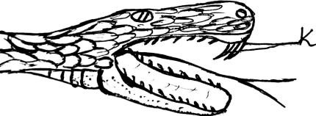Use the diagram below to answer questions that follow.
     1. Name the part marked K

…………………………………………………………………………………………………………………………

* + 1. What type of snake is shown in the diagram?

…………………………………………………………………………………………………….………………………

* + 1. Give any one example of such a snake.

………………………………………….…………………………………………………………………………………

* + 1. How are snakes important to crop farmers?

…………………………………………………………………………………………………………………………….

Turn over

* 1. State the main product a farmer obtains from each of the following breeds of goats

1. Saanen goats

……………………………………………………………………………………………………………………………

1. Angora goats

……………………………………………………………………………………………………………………………

b) Give any two ways a farmer can care for goats at home i)…………………………………………………………………………………………………………………………. ii)…………………………………………………………………………………………………………………………

* 1. a) Give the importance of air sacs found in the lungs

……………………………………………………………………………………………………………………………

1. Give any one way air sacs are adapted to their function

…………………………………………………………………………………………………………………………….

1. Name the body system to which the lungs belong

…………………………………………………………………………………………………………………………….

1. Mention any one communicable disease which affects the lungs.

……………………………………………………………………………………………………………………………

* 1. a) Give the meaning of the term dehydration

……………………………………………………………………………………………………………………………

Turn over

1. Name the two solutes used to prepare ORS at home i)…………………………………………………………………………………………………………………. ii)…………………………………………………………………………………………………………………
2. Why should dehydrated baby be given ORS?

…………………………………………………………………………………………………………………………

* 1. Use the diagram below to answer questions that follow

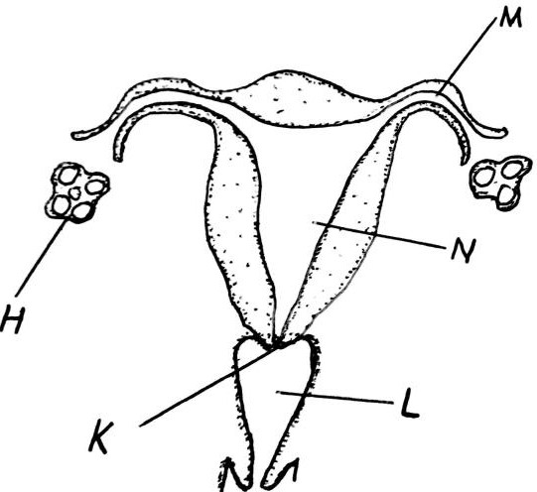

* + 1. Name part H

………………………………………………………………………………………………………..……………………

Turn over

* + 1. State the function of part K

……………………………………………………………………………………………………………………………..

* + 1. Give any one important process which occurs in part marked M

………………………………………………………………………………………………………………………..……

* + 1. Mention any one disorder of the body system shown

…………………………………………………………………………………………………………………………..…

* 1. a) Name the insect which lays eggs on faeces and other rotting materials

…………………………………………………………………………………………………………………………….

1. Give reason why the above mentioned insect lays eggs on faeces

…………………………………………………………………………………………………………………………….

1. Give any two examples of insects which undergo an incomplete life cycle
   1. ………………………………………………………………………………………………………………………….
   2. ………………………………………………………………………………………………………………………..
   3. Give the meaning of the following terms as used in magnetism
2. Magnetization

……………………………………………………………………………………………………………………………

……………………………………………………………………………………………………………………………

…………………………………………………………………………………………………………………………….

Turn over

1. Demagnetization

……………………………………………………………………………………………………………………………..

……………………………………………………………………………………………………………………………..

* 1. Give any two causes of demagnetization i)…………………………………………………………………………………………………………………… ii)…………………………………………………………………………………………………………………….
  2. Use the pulley system below to answer questions that follow

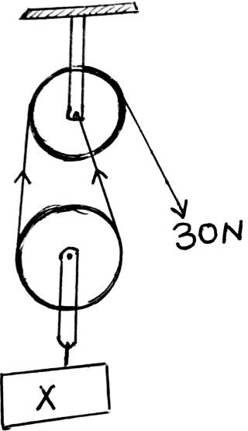

1. Name the pulley system shown

…………………………………………………………………….

Turn over

1. Give any one advantage of using the pulley system to lift a very heavy load

……………………………………………………………………………………………………………………………

1. Calculate and show the value of x. (2 marks)
   1. a)What do we call moving air?

……………………………………………………………………………………………………………………………..

* 1. Give any two ways people use moving air as a resource i)……………………………………………………………………………………………………………………

ii) …………………………………………………………………………………………………………………………..

* 1. State any one danger of moving air in the environment

……………………………………………………………………………………………………………………………..

* 1. a) State the function of hooks and suckers to a tape worm.

……………………………………………………………………………………………………………………………..

1. How do tape worms obtain food?

……………………………………………………………………………………………………………………………..

1. Mention the way tape worms invade the body

……………………………………………………………………………………………………………………………..

Turn over

1. Give any one way of preventing worm infestations in humans

……………………………………………………………………………………………………………………………..

* 1. a) Give any one example of weed in the garden

……………………………………………………………………………………………………………………………..

1. State any one danger of weeds in the garden.

……………………………………………………………………………………………………………………………

1. Mention any two ways of removing weeds from the garden

……………………………………………………………………………………………………………………………..

……………………………………………………………………………………………………………………………..

2024 SPECIAL MOCK

# END